Chamber Executive Board Meeting
11:30-12:30 Zoom
Tuesday, May 3, 2022

  - Attendees: Joe Prodinsky Sarah Wischnefski Karen Kuhn Tracey Hoeschen Brad Eckhoff Jude DuHoux
  - Call to Order
  - Previous Month’s Chamber Executive Board Meeting Minutes
    - Motion to approve by: Brad Eckhoff
    - Motioned seconded by: Sarah

  - Previous Month’s Treasurer’s Report- (Reading & approval expenses & revenues)
    - Motion to approve by: Joe Prodinsky
    - Motioned seconded by: Karen
  - Membership
      - Russell Eyecare
      - Morgan Sand
      - David Miller, Kensington Bank in St. Cloud
      - Not much activity happening on the payment front
      - Deters is from last year
      - Will send personally labelled email again
  - Meeting
    - May’s Meeting: State of the City
    - Kay’s Again, caterers are not abundant
    - Room Cleaning
  - Marketing
    - Business Cards
    - I may have failed to tell you about Showcase…sorry.
    - Items in storage: Looked for online sites to post our Chamber meeting date (6)
    - Need to advertise free Business After Hours and procedures for this event including the option of having a Tri-Chamber Event
      - Russell
  - Good of the Chamber (Fan mail, donation requests etc.)
    - Business After Hours…not charging…is that okay. Russell Eyecare (Tri-Chamber Event)
    - Next year’s Showcase discussion.
    - Share BAH with Regular membership and put it in newsletter
    - Jude
  - Adjourn
    - Motion to adjourn by: Brad Eckhoff
    - Motion seconded by: Sarah W.

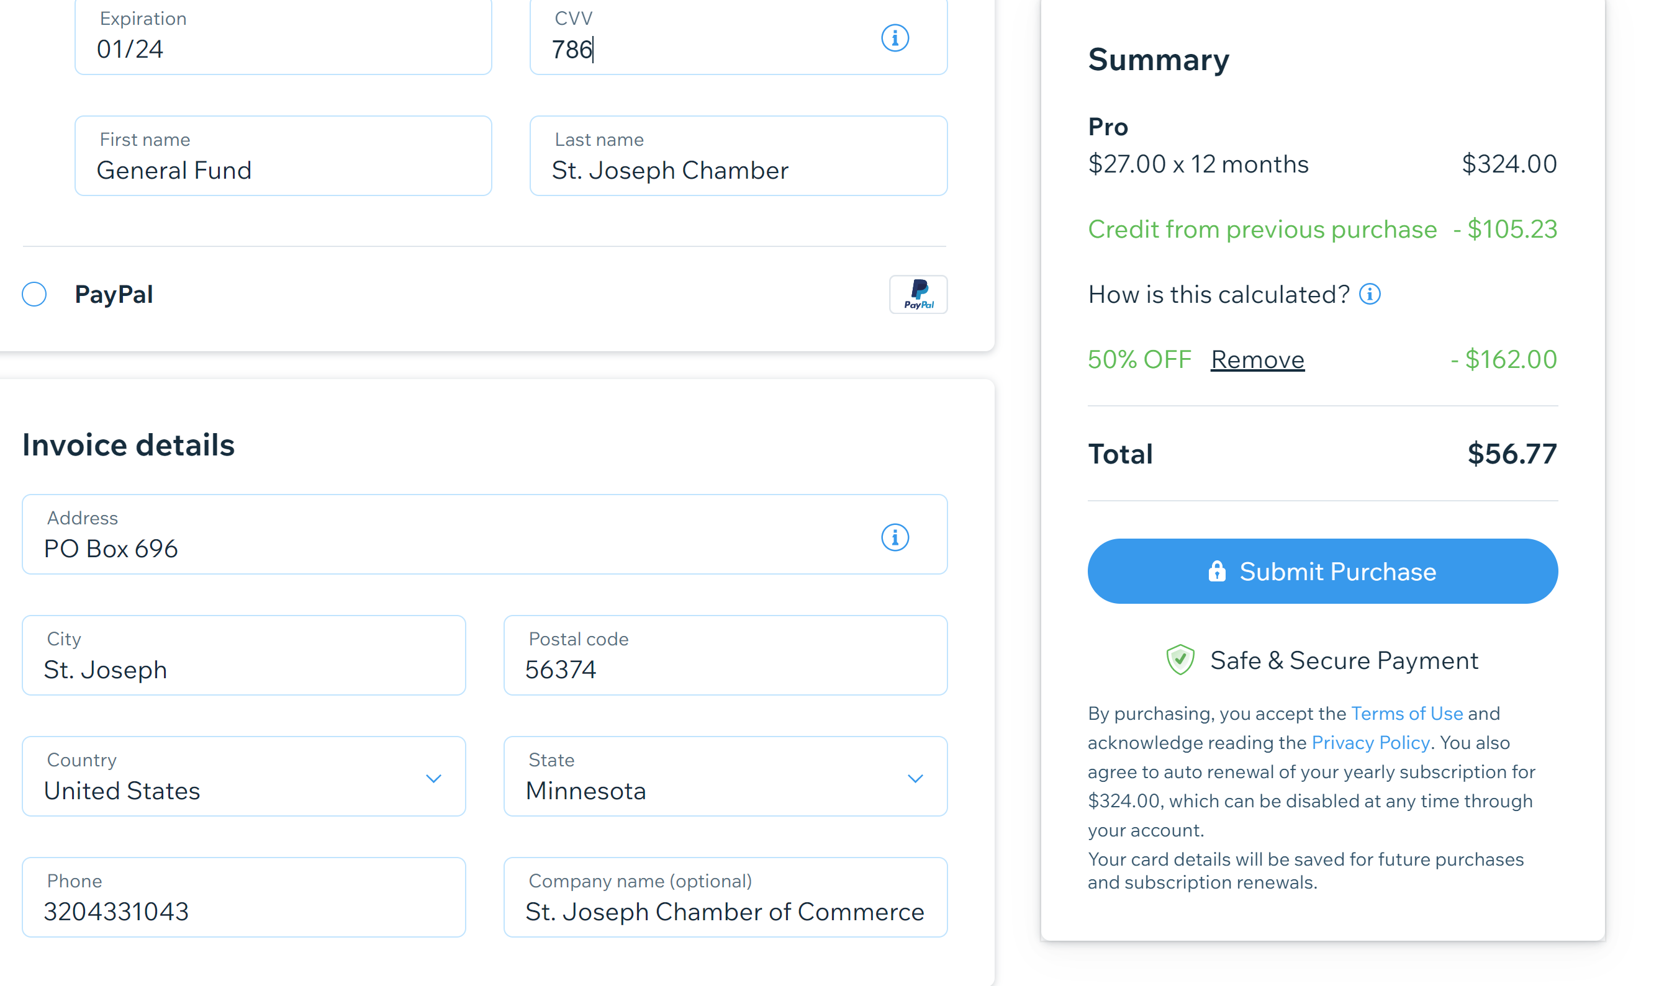

Companies that have unsubscribed, or let me know they are not interested and haven’t been members for more than 3 years.

American Manufacturing
Bliss Media Direct
Dierkes Heating
Short Stop
Kluescher Financial
MN Public Radio
Cedar Street Salon
Voight Johnson Realty
Cohlab
McDonald’s

Companies I sent individual emails to to ask if they had just forgot to pay or have chosen not to be members.
Accounting Solutions LLC / Money Matters
Animart / Armor Animal Health
Bello Cucina
BoDiddleys Deli
Collegeville Communities
Computer Repair Unlimited
Keller Williams / Cory Inc
Deters Accounting & Tax Service LLC
Dijital Majik Computers
Dr. Michael F Contardo DDS / Laser Dentistry
Edward Jones - Beau Hanowski
Granite Services, LLC
Jovanovich, Kadlec & Athmann, PLLP
Kwik Trip, Inc
Mary Kay Independent Beauty Consultant
McDonald's Restaurant - Jova Mgmt LLC
Medelberg Family Chiropractic
MN Street Market
Precise Refrigeration Heating & AC
Promotional Resources
Retro Green Energy
Sharing (Shaklee)
Short Elliott Hendrickson Inc
St John's Prep
Exponential Chiropractic

Speaker procurement and ideas:
Derek DuHoux, Apache Helicopter Pilot “The American Flag
Doniel Robinson 320-631-2018 Initiative Foundation
Light The Legacy Lynn McKenzie 320-774-0911
Claudia Reverman “power of attorney” and “estate planning” 320-258-9383

- Content Marketing in Minutes a Day
- Turning Customers into Brand Ambassa”dors
- Unexpected Ways to Delight Your Customers for Little to No Money
- Scaling your business, going from one employee to the next level.
- How to hire critical business partners (like attorneys, financial planners, virtual assistants, and others).
- Making a name for yourself in the community (as a thought leader or a branding exercise).
- Implementing a wellness program or wellness benefits.
- The value of selecting and marketing your niche.
- How to begin selling online.
- Tips on grant writing, RFPs, or submitting government bids.
- Creating a successful referral or loyalty program.
- Recruiting and keeping the younger generation.
- 15 ways to make the most of your chamber membership.
- How to avoid career burnout.
- Tips for improving your customer service.

